Evan Gertis

**Assignment 5**

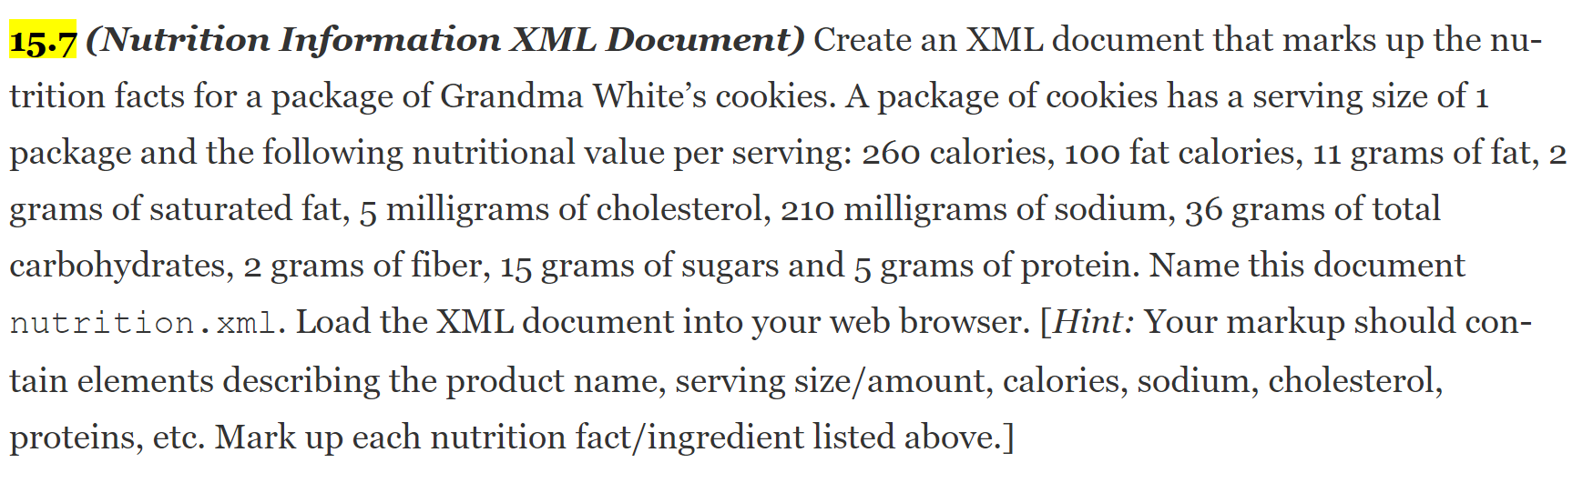

<?xml version = "1.0" ?>

<cookies>

    <servingsize>1</servingsize>

    <calories>260</calories>

    <caloriesfromfat>100</caloriesfromfat>

    <gfat>11</gfat>

    <gsaturatedfat>2</gsaturatedfat>

    <mgcholesterol>5</mgcholesterol>

    <mgsodium>5</mgsodium>

</cookies>

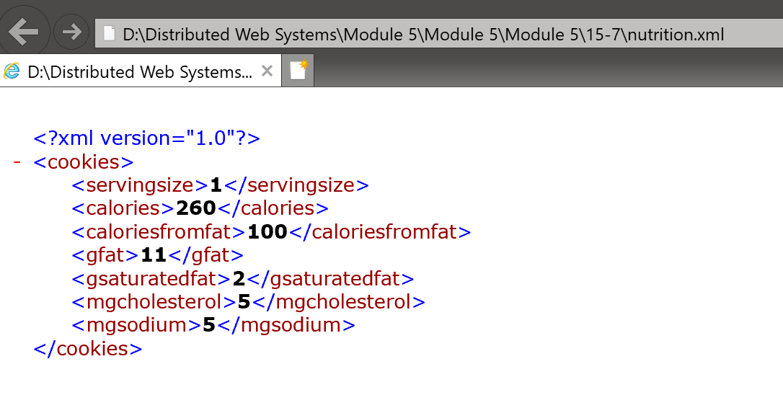

  
<?xml version="1.0" encoding="UTF-8"?>

<xs:schema xmlns:xs="http://www.w3.org/2001/XMLSchema">

    <xs:element name="cookies">

        <xs:complexType>

            <xs:sequence>

                <xs:element name="recipe">

                    <xs:complexType>

                        <xs:sequence>

                            <xs:element name="servingsize" type="xs:string" />

                            <xs:element name="calories" type="xs:string" />

                            <xs:element name="caloriesfromfat" type="xs:string" />

                            <xs:element name="gfat" type="xs:string" />

                            <xs:element name="gsaturatedfat" type="xs:string" />

                            <xs:element name="mgcholesterol" type="xs:string" />

                            <xs:element name="mgsodium" type="xs:string" />

                        </xs:sequence>

                    </xs:complexType>

                </xs:element>

            </xs:sequence>

        </xs:complexType>

    </xs:element>

</xs:schema>



<?xml version="1.0" encoding="UTF-8"?>

<html xsl:version="1.0" xmlns:xsl="http://www.w3.org/1999/XSL/Transform">

    <body style="font-family:Arial;font-size:12pt;background-color:#EEEEEE">

        <table>

            <caption>Grandma White's Cookies</caption>

            <thead>

                <tr>

                    <th>servingsize</th>

                    <th>calories</th>

                    <th>caloriesfromfat</th>

                    <th>gfat</th>

                    <th>gsaturatedfat</th>

                    <th>mgcholesterol</th>

                    <th>mgsodium</th>

                </tr>

            </thead>

            <xsl:for-each select="cookies">

                <tr>

                    <td>

                        <xsl:value-of select="servingsize" />

                    </td>

                    <td>

                        <xsl:value-of select="calories" />

                    </td>

                    <td>

                        <xsl:value-of select="caloriesfromfat" />

                    </td>

                    <td>

                        <xsl:value-of select="gfat" />

                    </td>

                    <td>

                        <xsl:value-of select="gsaturatedfat" />

                    </td>

                    <td>

                        <xsl:value-of select="mgcholesterol" />

                    </td>

                    <td>

                        <xsl:value-of select="mgsodium" />

                    </td>

                </tr>

            </xsl:for-each>

        </table>

    </body>

</html>

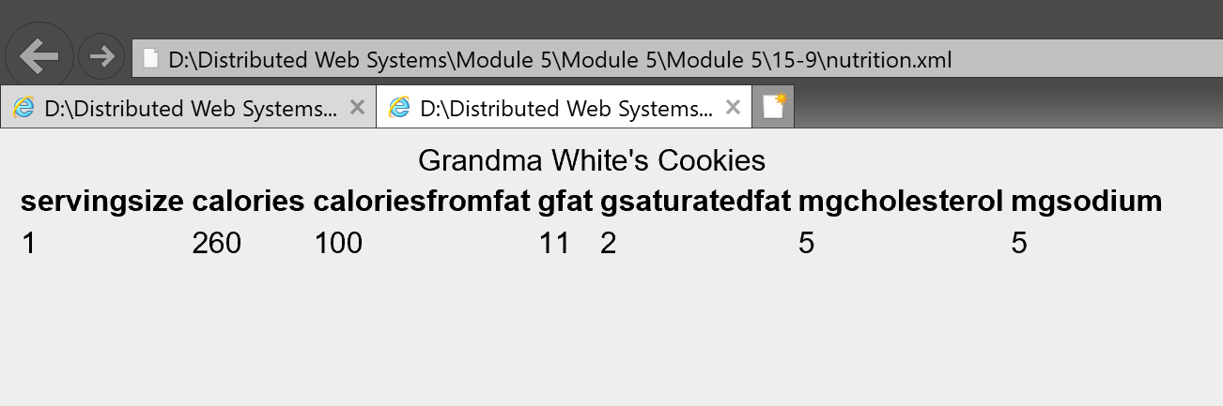



<?xml version = "1.0"?>

<!-- Fig. 24.17: sorting.xsl -->

<!-- Transformation of book information into XHTML -->

<xsl:stylesheet version = "1.0" xmlns = "http://www.w3.org/1999/xhtml"

   xmlns:xsl = "http://www.w3.org/1999/XSL/Transform">

   <!-- write XML declaration and DOCTYPE DTD information -->

   <xsl:output method = "xml" omit-xml-declaration = "no"

      doctype-system = "http://www.w3.org/TR/xhtml11/DTD/xhtml11.dtd"

      doctype-public = "-//W3C//DTD XHTML 1.1//EN"/>

   <!-- match document root -->

   <xsl:template match = "/">

      <html>

         <xsl:apply-templates/>

      </html>

   </xsl:template>

   <!-- match book -->

   <xsl:template match = "book">

      <head>

         <title>ISBN <xsl:value-of select = "@isbn"/> -

            <xsl:value-of select = "title"/></title>

      </head>

      <body>

         <h1 style = "color: blue"><xsl:value-of select = "title"/></h1>

         <h2 style = "color: blue">by

            <xsl:value-of select = "author/firstName"/>

            <xsl:text> </xsl:text>

            <xsl:value-of select = "author/lastName"/>

         </h2>

         <table style = "border-style: groove; background-color: gold">

            <xsl:for-each select = "chapters/frontMatter/*">

               <tr>

                  <td style = "text-align: right">

                     <xsl:value-of select = "name()"/>

                  </td>

                  <td>

                     ( <xsl:value-of select = "@pages"/> pages )

                  </td>

               </tr>

            </xsl:for-each>

            <xsl:for-each select = "chapters/chapter">

               <xsl:sort select = "@pages" data-type = "number"

                    order = "descending"/>

               <tr>

                  <td style = "text-align: right">

                     Chapter <xsl:value-of select = "@number"/>

                  </td>

                  <td>

                     <xsl:value-of select = "text()"/>

                     ( <xsl:value-of select = "@pages"/> pages )

                  </td>

               </tr>

            </xsl:for-each>

            <xsl:for-each select = "chapters/appendix">

               <xsl:sort select = "@pages" data-type = "text"

                  order = "ascending"/>

               <tr>

                  <td style = "text-align: right">

                     Appendix <xsl:value-of select = "@pages"/>

                  </td>

                  <td>

                     <xsl:value-of select = "text()"/>

                     ( <xsl:value-of select = "@pages"/> pages )

                  </td>

               </tr>

            </xsl:for-each>

         </table>

    <p style = "color: blue">Pages:

            <xsl:variable name = "pagecount"

               select = "sum(chapters//*/@pages)"/>

            <xsl:value-of select = "$pagecount"/>

         <br />Media Type: <xsl:value-of select = "media/@type"/></p>

      </body>

   </xsl:template>

</xsl:stylesheet>

<?xml version = "1.0"?>

<!-- Fig. 24.16: sorting.xml -->

<!-- XML document containing book information -->

<?xml-stylesheet type = "text/xsl" href = "sorting.xsl"?>

<book isbn = "999-99999-9-X">

   <title>Deitel&apos;s XML Primer</title>

   <author>

      <firstName>Jane</firstName>

      <lastName>Blue</lastName>

   </author>

   <chapters>

      <frontMatter>

         <preface pages = "2" />

         <contents pages = "5" />

         <illustrations pages = "4" />

      </frontMatter>

      <chapter number = "3" pages = "44">Advanced XML</chapter>

      <chapter number = "2" pages = "35">Intermediate XML</chapter>

      <appendix number = "B" pages = "26">Parsers and Tools</appendix>

      <appendix number = "A" pages = "7">Entities</appendix>

      <chapter number = "1" pages = "28">XML Fundamentals</chapter>

   </chapters>

   <media type = "CD" />

</book>

